**AI – Assignment 2**

K. Sheetal Reddy

14XJ1A0526

1. **Egg Holder Function:**

Comparision:

The plots for the population size: 20, 50, 200,200

Number of Generations : 50,100, 200

As the graphs given below suggest, as the number of population sample increases and the number of generations increase, the optimized solution gets closer to the actual solution.

Correct Solution : -**959.6407**

Least number scenario: Population size: 20 and Number of Generations: 50

Value: -847.384002875

Error % = 11.6977840899

Least number scenario: Population size: 10 and Number of Generations: 50

Value: -958.258389512

Error % = 0.144044587521

Error Percentages:

|  |  |  |  |  |
| --- | --- | --- | --- | --- |
| Population Size / Number of Gen : | 20 | 50 | 100 | 200 |
| 50 | 11.6977840899 | 5.84364135733 | 0.0179196366192 | 2.00029921897 |
| 100 | 3.25812778012 | 2.60757594462 | 0.715374302903 | 0.543761445925 |
| 200 | 0.568332479958 | 0.753447173927 | 0.676824053836 | 0.144044587521 |

Population :20 Number of Generations : 50

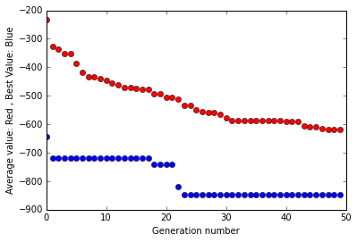 Value : -847.384002875

Population :20 Number of Generations : 100

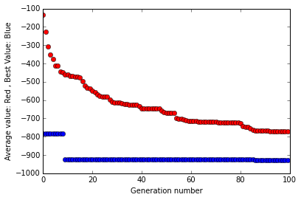 Value : -928.374379764

Population :20 Number of Generations : 200

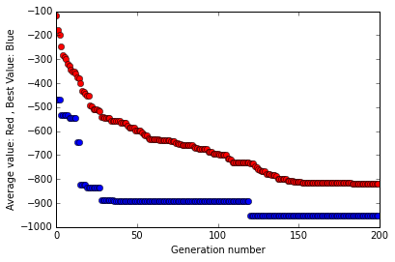 Value: -954.186750211

Population :50 Number of Generations : 50

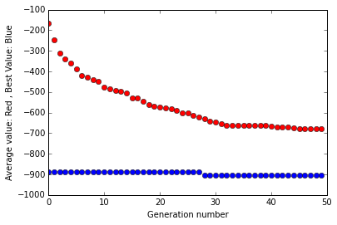 Value: -903.562739173

Population :50 Number of Generations : 100

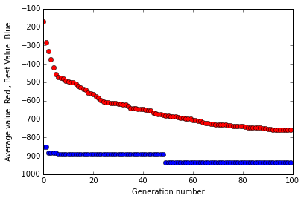 Value: -934.617339952

Population :50 Number of Generations : 200

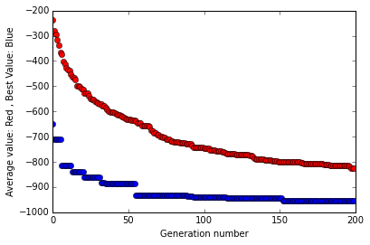 Value :-952.410314266

Population :100 Number of Generations : 50

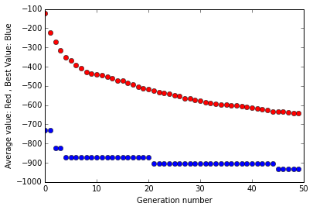 Value: -904.223935123

Population :100 Number of Generations : 100

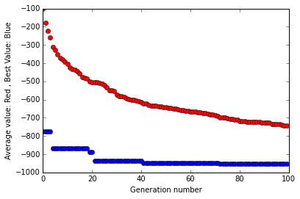 Value: -952.775677032

Population :100 Number of Generations : 200

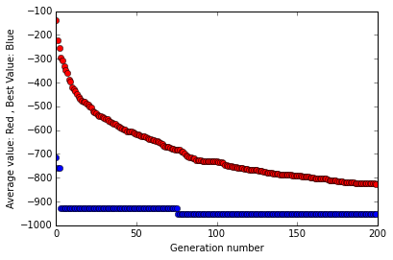 Value: -953.14562091

Population :200 Number of Generations : 50

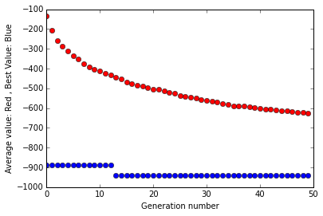

Value : -940.445014573

Population :200 Number of Generations : 100

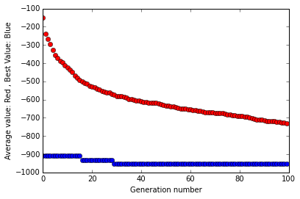 Value: -954.422543854

Population :200 Number of Generations : 200

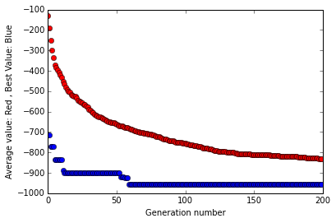 Value: - 958.258389512

1. **Holder Table Function:**

Comparision:

The plots for the population size: 20, 50, 200,200

Number of Generations : 50,100, 200

As the graphs given below suggest, as the number of population sample increases and the number of generations increase, the optimized solution gets closer to the actual solution.

In this case due to a much smaller range of values, the values get converge to the optimum faster.

Correct Solution : -**19.2085**

Least number scenario: Population size: 20 and Number of Generations: 50

Value: -19.0991441782

Error % = 0.5693095338

Least number scenario: Population size: 10 and Number of Generations: 50

Value: -19.2085025592

Error % = 0.00001332

Error Percentages:

|  |  |  |  |  |
| --- | --- | --- | --- | --- |
| Population Size / Number of Gen : | 20 | 50 | 100 | 200 |
| 50 | 0.5693095338 | 0.0354924575058 | 0.0179196366192 | 0.00430292839108 |
| 100 | 0.0005777364 | 0.000716896686373 | 0.00153343467735 | 0.00034869250592 |
| 200 | 0.00001274 | 0.000010929 | 0.00001192 | 0.00001332 |

Population :20 Number of Generations : 50

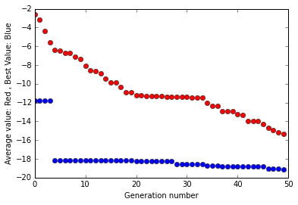 Value: -19.0991441782

Population :20 Number of Generations : 100

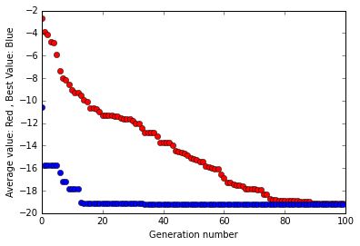 .Value : -19.2083890255

Population :20 Number of Generations : 200

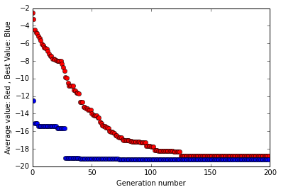 Value:-19.208502377

Population :50 Number of Generations : 50

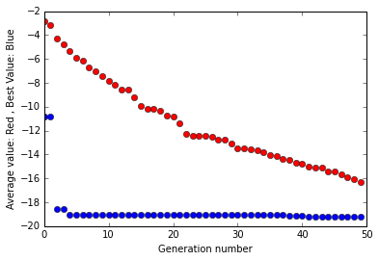 Value: -19.2016824313

Population :50 Number of Generations : 100

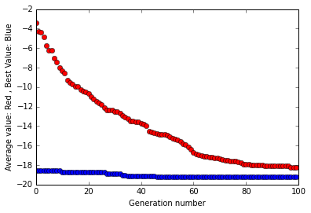 Value: -19.2083622949

Population :50 Number of Generations : 200

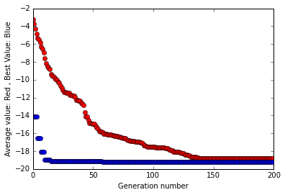 Value: -19.2085020994

Population :100 Number of Generations : 50

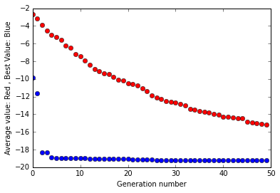 Value: -19.2050579066

Population :100 Number of Generations : 100

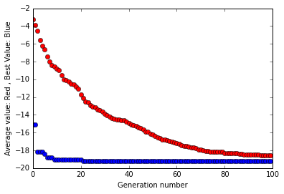 Value : -19.2082054502

Population :100 Number of Generations : 200

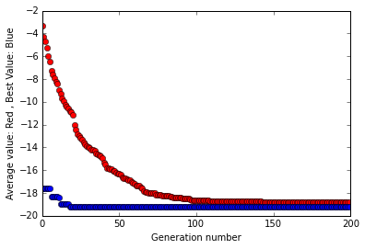 Value: -19.2085022902

Population :200 Number of Generations : 50

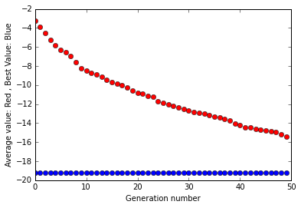 Value: -19.207673472

Population :200 Number of Generations : 100

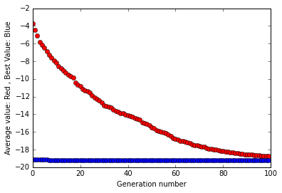 Value: -19.2084330214

Population :200 Number of Generations : 200

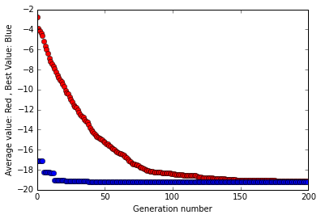 Value:-19.2085025592